**Discovery 1: Investigate the CAM**

**Job Aid**

|  |
| --- |
| Note |
| If you shut down an interface on a real router or switch, the connected device will see it as "down/down." Due to virtualization specifics, IOL behavior is slightly different. If you shut down an interface on a router or switch, the connected device will see it as "up/up." In IOL, the status of an interface can only be "up/up" or "administratively down/down.  Device Information. |

**Topology**

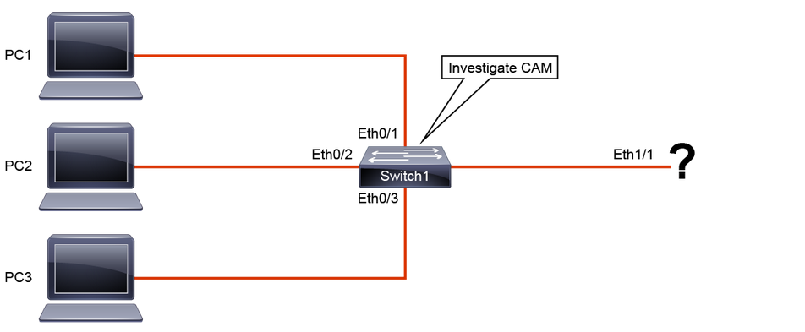

| **Device** | **Device IP** | **Device Interface** | **Neighbor** | **Interface on the Neighbor** |
| --- | --- | --- | --- | --- |
| PC1 | 10.1.1.1 | Eth0/0 | Switch1 | Eth0/0 |
| PC2 | 10.1.1.2 | Eth0/0 | Switch1 | Eth0/1 |
| PC3 | 10.1.1.3 | Eth0/0 | Switch1 | Eth0/2 |
| Switch1 | Not applicable | Eth1/1 | Not applicable | Not applicable |

**Discovery 2: Analyze Cisco Express Forwarding**

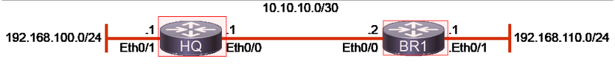

The network connectivity and IPv4 addressing for the lab is given here.

| Device Information | | | |
| --- | --- | --- | --- |
| **Device** | **Interface** | **Neighbor** | **IP Address** |
| HQ | Ethernet 0/0 | BR1 | 10.10.10.1/30 |
| HQ | Ethernet 0/1 | / | 192.168.100.1/24 |
| BR1 | Ethernet 0/0 | HQ | 10.10.10.2/30 |
| BR1 | Ethernet 0/1 | / | 192.168.110.1/24 |

**Discovery 3: Troubleshoot VLAN and Trunk Issues**

Job Aids

There are no job aids available for this lab exercise, because one of the objectives of the lab is to map the connectivity within an unfamiliar network.

Topology

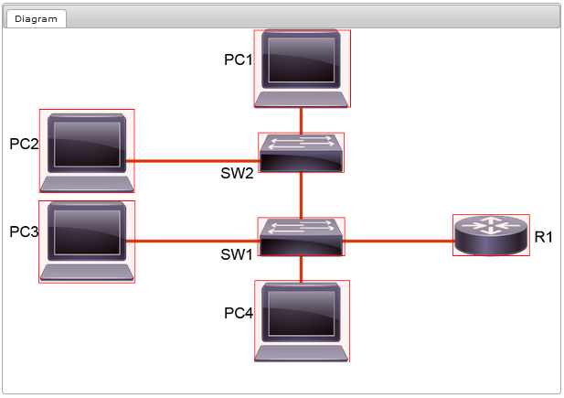

Note

PCs in the virtual lab environment are simulated as routers, so you should use Cisco IOS commands to configure them or make verifications.

**Discovery 4: Tuning STP and Configuring RSTP**

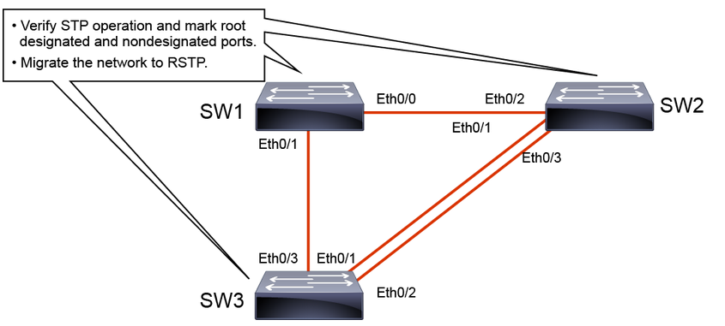

Job Aid

Note

If you shut down an interface on a real router or switch, the connected device will see it as "down/down." Due to virtualization specifics, IOL behavior is slightly different. If you shut down an interface on a router or switch, the connected device will see it as "up/up." In IOL, the status of an interface can only be "up/up" or "administratively down/down.

There are no Job Aids for this lab.

**Discovery 5: Configure Multiple Spanning Tree Protocol**

Job Aid

Topology

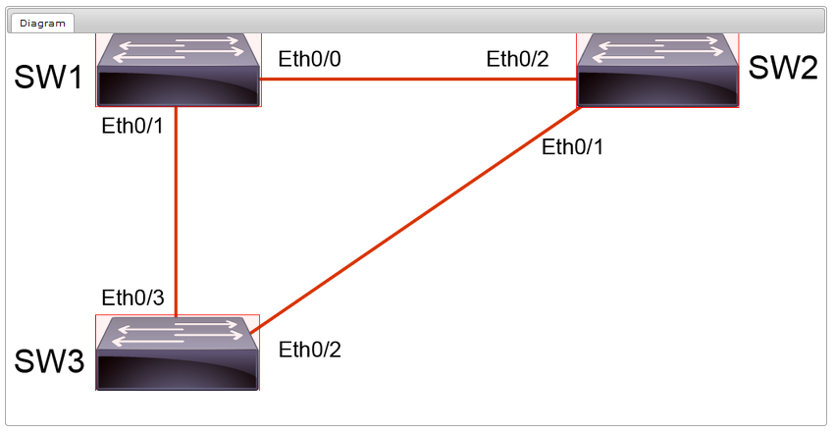

Note

If you shut down an interface on a real router or switch, the connected device will see it as "down/down." Due to virtualization specifics, IOL behavior is slightly different. If you shut down an interface on a router or switch, the connected device will see it as "up/up." In IOL, the status of an interface can only be "up/up" or "administratively down/down.

Device Information

| **Device** | **Interface** | **Neighbor** | **Neighbor Interface** |
| --- | --- | --- | --- |
| SW1 | Eth0/0 | SW2 | Eth0/2 |
| SW1 | Eth0/1 | SW3 | Eth0/3 |
| SW2 | Eth0/1 | SW3 | Eth0/2 |

**Discovery 6: Troubleshoot EtherChannel**

**Topology**

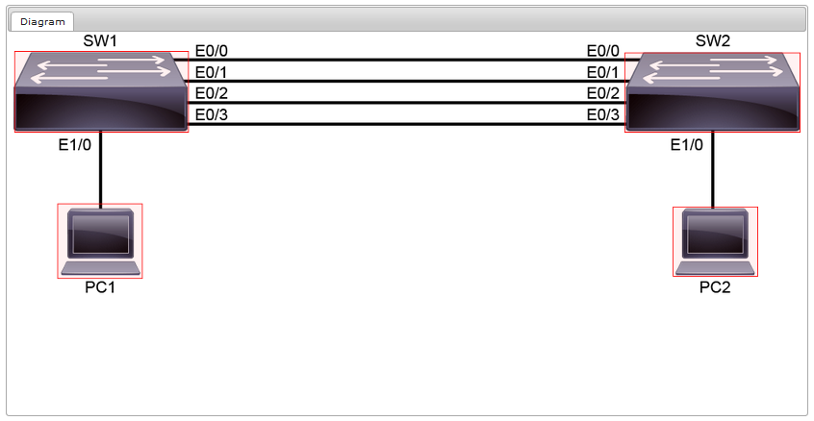

Job Aid

Note

If you shut down an interface on a real router or switch, the connected device will see it as "down/down." Due to virtualization specifics, Cisco IOL (Cisco IOS Software on Linux) behavior is slightly different. If you shut down an interface on a router or switch, the connected device will see it as "up/up." In Cisco IOL, the status of an interface can only be "up/up" or "administratively down/down." Also, in the virtual lab environment, all interfaces are Ethernet interfaces and not FastEthernet or GigabitEthernet interfaces, which you are likely to encounter in networks today.

Device Information

| **Device** | **Remote Device Connection** |
| --- | --- |
| SW1 (Ethernet 0/0) | SW2 (Ethernet 0/0) |
| SW1 (Ethernet 0/1) | SW2 (Ethernet 0/1) |
| SW1 (Ethernet 0/2) | SW2 (Ethernet 0/2) |
| SW1 (Ethernet 0/3) | SW2 (Ethernet 0/3) |
| SW1 (Ethernet 1/0) | PC1 (10.10.11.11) |
| SW2 (Ethernet 1/0) | PC2 (10.10.11.12) |

**Discovery 7: Implement Multiarea OSPF**

Topology

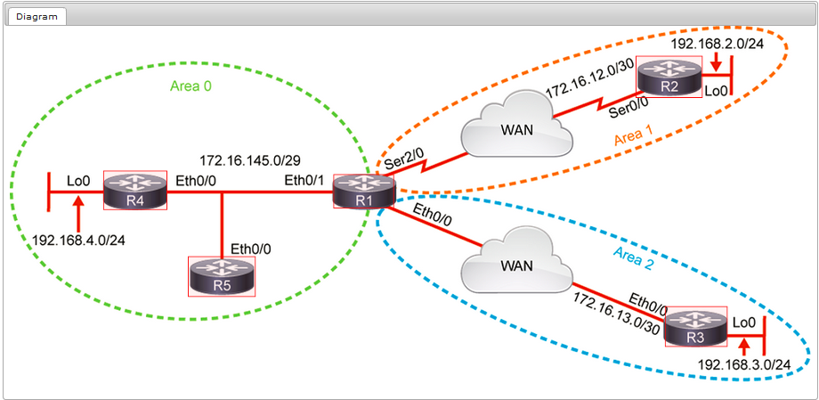

Job Aid

The configuration is as follows:

* All devices have their basic configurations in place, including hostnames and IP addresses.
* R4 and R5 are preconfigured with OSPF.

Note

If you shut down an interface on a real router or switch, the connected device will see it as "down/down." Due to virtualization specifics, IOL behavior is slightly different. If you shut down an interface on a router or switch, the connected device will see it as "up/up." In IOL, the status of an interface can only be "up/up" or "administratively down/down."

| Device Information | | | |
| --- | --- | --- | --- |
| **Device** | **Interface** | **Neighbor** | **IP Address** |
| R1 | Ethernet0/0 | 172.16.13.1/30 | Connection to R3 |
| R1 | Ethernet0/1 | 172.16.145.1/29 | Connection to R4 and R5 |
| R1 | Serial2/0 | 172.16.12.1/30 | Connection to R2 |
| R2 | Loopback0 | 192.168.2.1/24 | Loopback simulates a LAN network |
| R2 | Serial0/0 | 172.16.12.2/30 | WAN connection to R1 |
| R3 | Loopback0 | 192.168.3.1/24 | Loopback simulates a LAN network |
| R3 | Ethernet0/0 | 172.16.13.2/30 | WAN connection to the R1 |
| R4 | Loopback0 | 192.168.4.1/24 | Loopback simulates a LAN network |
| R4 | Ethernet0/0 | 172.16.145.4/29 | Connection to R1 and R5 |
| R5 | Ethernet0/0 | 172.16.145.5/29 | Connection to R1 and R4 |

**Discovery 8: Implement OSPF Tuning**

Topology

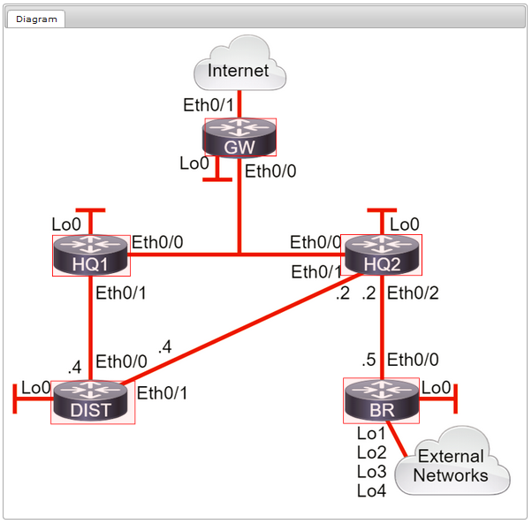

Job Aid

The configuration is as follows:

* All devices have their basic configurations in place, including hostnames and IP addresses.
* All routers are preconfigured with OSPF.
* Router BR is advertising four external networks into OSPF

Note

If you shut down an interface on a real router or switch, the connected device will see it as "down/down." Due to virtualization specifics, IOL behavior is slightly different. If you shut down an interface on a router or switch, the connected device will see it as "up/up." In IOL, the status of an interface can only be "up/up" or "administratively down/down."

Device Connections

| **Device** | **Interface** | **Connects To** | **Neighbor Interface** |
| --- | --- | --- | --- |
| DIST | Ethernet 0/0 | HQ1 | Ethernet 0/1 |
| DIST | Ethernet 0/1 | HQ2 | Ethernet 0/1 |
| BR | Ethernet 0/0 | HQ2 | Ethernet 0/2 |
| HQ1 | Ethernet 0/0 via SW | HQ2 | Ethernet 0/0 via SW |
| HQ1 | Ethernet 0/0 via SW | GW | Ethernet 0/0 via SW |
| HQ2 | Ethernet 0/0 via SW | GW | Ethernet 0/0 via SW |
| GW | Ethernet 0/1 | Internet | — |

Device IP Address Information

| **Device** | **Interface** | **IP Address** |
| --- | --- | --- |
| HQ1 | Ethernet 0/0 | 172.16.123.1/25 |
| HQ1 | Ethernet 0/1 | 172.16.14.1/28 |
| HQ2 | Ethernet 0/0 | 172.16.123.2/25 |
| HQ2 | Ethernet 0/1 | 172.16.24.2/28 |
| HQ2 | Ethernet 0/2 | 172.16.25.2/28 |
| GW | Ethernet 0/0 | 172.16.123.3/25 |
| GW | Ethernet 0/1 | 10.1.1.253/24 |
| DIST | Ethernet 0/0 | 172.16.14.4/28 |
| DIST | Ethernet 0/1 | 172.16.24.4/28 |
| BR | Ethernet 0/0 | 172.16.25.5/28 |
| HQ1 | Loopback 0 | 192.168.1.1/32 |
| HQ2 | Loopback 0 | 192.168.2.2/32 |
| GW | Loopback 0 | 192.168.3.3/32 |
| DIST | Loopback 0 | 192.168.4.4/32 |
| BR | Loopback 0 | 192.168.5.5/32 |
| BR | Loopback 1 | 10.1.1.1/24 |
| BR | Loopback 2 | 10.2.2.1/24 |
| BR | Loopback 3 | 10.3.3.1/24 |
| BR | Loopback 4 | 10.4.4.1/24 |

Router ID Information

|  |  |
| --- | --- |
| Device | Router ID |
| HQ1 | 1.1.1.1 |
| HQ2 | 2.2.2.2 |
| GW | 3.3.3.3 |
| DIST | 4.4.4.4 |
| BR | 5.5.5.5 |

**Discovery 9: Apply OSPF Optimization**

**Topology**

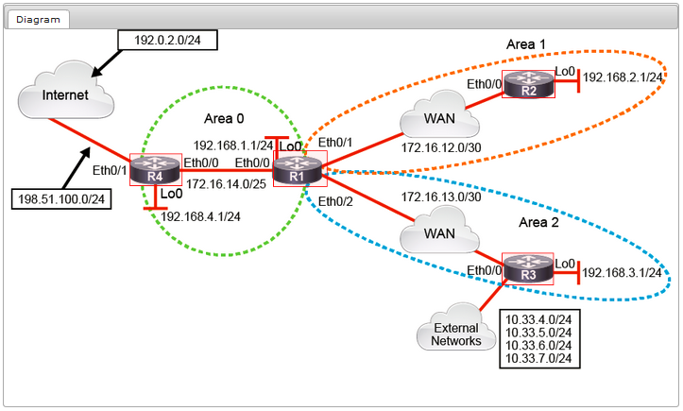

Job Aid

The configuration is as follows:

* All devices have their basic configurations in place, including hostnames and IP addresses. Routers R1 to R4 are preconfigured with OSPF.
* Static routing is used to reach Internet networks.
* R3 is advertising four external networks.

| Device Information | | | |
| --- | --- | --- | --- |
| **Device** | **Interface** | **Neighbor** | **IP Address** |
| R1 | Loopback0 | 192.168.1.1/24 | Loopback simulates a LAN network |
| R1 | Ethernet0/0 | 172.16.14.1/25 | Connection to R4 |
| R1 | Ethernet0/1 | 172.16.12.1/30 | Connection to R2 |
| R1 | Ethernet0/2 | 172.16.13.1/30 | Connection to R3 |
| R2 | Loopback0 | 192.168.2.1/24  192.168.16.1/24  192.168.17.1/24  192.168.18.1/24  192.168.19.1/24  192.168.20.1/24  192.168.21.1/24  192.168.22.1/24  192.168.23.1/24 | Loopback simulates LAN networks |
| R2 | Ethernet0/0 | 172.16.12.2/30 | WAN connection to R1 |
| R3 | Loopback0 | 192.168.3.1/24  10.33.4.1/24  10.33.5.1/24  10.33.6.1/24  10.33.7.1/24 | Loopback simulates LAN and external networks |
| R3 | Ethernet0/0 | 172.16.13.2/30 | WAN connection to the R1 |
| R4 | Loopback0 | 192.168.4.1/24 | Loopback simulates a LAN network |
| R4 | Ethernet0/0 | 172.16.14.2/25 | Connection to R1 |
| R4 | Ethernet0/1 | 198.51.100.1/24 | Connection to Internet |
| Internet | Loopback0 | 192.0.2.1/24 | Loopback simulates an external Internet-hosted network |
| Internet | Enternet0/0 | 198.51.100.2/24 | Connection to R4 |

**Discovery 10: Implement OSPFv3s**

**Topology**

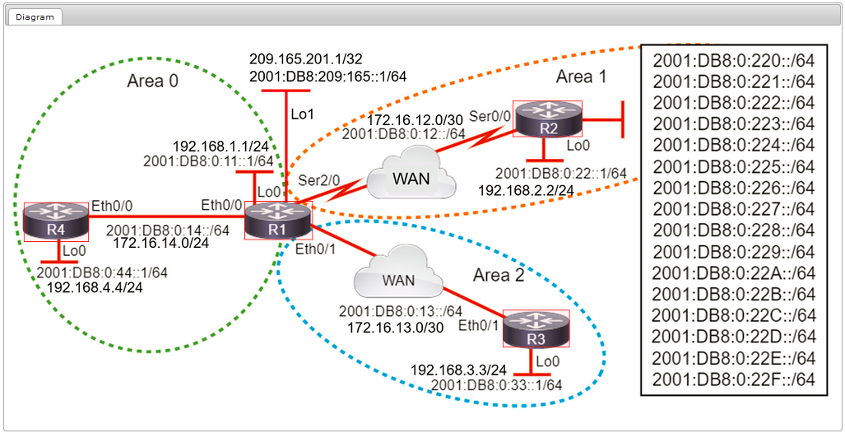

Job Aid

The configuration is as follows:

* All devices have their basic configurations in place, including hostnames and IP addresses.
* R2, R3, and R4 have OSPFv3 IPv4 and IPv6 address families configured.

| Device Information | | | |
| --- | --- | --- | --- |
| **Device** | **Interface** | **IP Addresses** | **Neighbor** |
| R1 | Ethernet0/0 | 172.16.13.1/30 2001:DB8:0:13::1/64 FE80::1 (link-local) | Connection to R3 |
| R1 | Ethernet0/1 | 172.16.14.1/24 2001:DB8:0:14::1/64 FE80::1 (link-local) | Connection to R4 |
| R1 | Serial2/0 | 172.16.12.1/30 2001:DB8:0:12::1/64 FE80::1 (link-local) | Connection to R2 |
| R1 | Loopback 0 | 192.168.1.1/24 2001:DB8:0:11::1/64 FE80::1 (link-local) | Loopback simulates a LAN network |
| R1 | Loopback 1 | 209.165.201.1/32 2001:DB8:209:165::1/64 | Loopback simulates an external connection |
| R2 | Loopback 0 | 192.168.2.2/24 2001:DB8:0:22::1/64 FE80::2 (link-local) | Loopback simulates a LAN network |
| R2 | Serial0/0 | 172.16.12.2/30 2001:DB8:0:12::2/64 FE80::2 (link-local) | WAN connection to R1 |
| R3 | Loopback 0 | 192.168.3.3/24 2001:DB8:0:33::1/64 FE80::3 (link-local) | Loopback simulates a LAN network |
| R3 | Ethernet0/0 | 172.16.13.2/30 2001:DB8:0:13::3/64 FE80::3 (link-local) | WAN connection to the R1 |
| R4 | Loopback 0 | 192.168.4.4/24 2001:DB8:0:44::1/64 FE80::4 (link-local) | Loopback simulates a LAN network |
| R4 | Ethernet0/0 | 172.16.14.4/24 2001:DB8:0:14::4/64 FE80::4 (link-local) | Connection to R1 |

**Discovery 11: Configure and Verify Single-Homed EBGP**

**Topology**

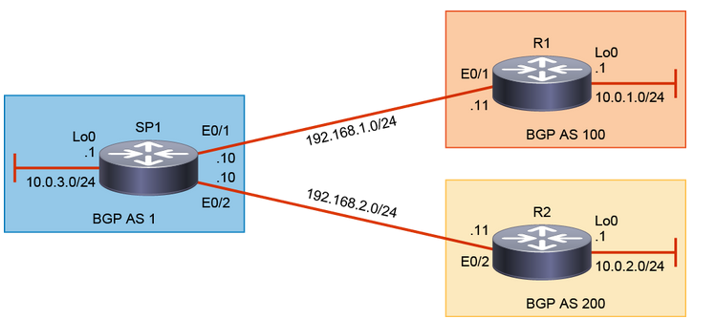

Job Aid

Device Information

| Device Details | | | |
| --- | --- | --- | --- |
| **Device** | **Interface** | **IP Address** | **Description** |
| SP1 | Ethernet0/1 | 192.168.1.10/24 | Connection to R1 |
| SP1 | Ethernet0/2 | 192.168.2.10/24 | Connection to R2 |
| SP1 | Loopback0 | 10.0.3.1/24 | Simulated LAN network |
| R1 | Ethernet0/1 | 192.168.1.11/24 | Connection to SP1 |
| R1 | Loopback0 | 10.0.1.1/24 | Simulated LAN network |
| R2 | Ethernet0/2 | 192.168.2.11/24 | Connection to SP1 |
| R2 | Loopback0 | 10.0.2.1/24 | Simulated LAN network |

| Device AS Information | |
| --- | --- |
| **Device** | **AS Number** |
| SP1 | AS 1 |
| R1 | AS 100 |
| R2 | AS 200 |

**Discovery 12: Implementing HSRP**

**Topology**

IP Addressing

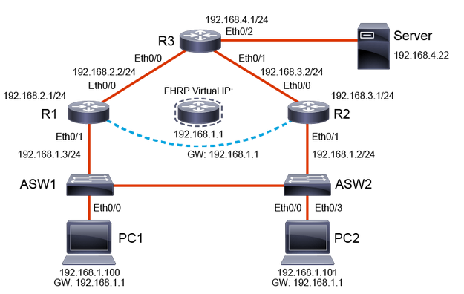

**Job Aid**

**Note**

If you shut down an interface on a real router or switch, the connected device will see it as "down/down." Due to virtualization specifics, IOL behavior is slightly different. If you shut down an interface on a router or switch, the connected device will see it as "up/up." In IOL, the status of an interface can only be "up/up" or "administratively down/down.

**Discovery 13: Configure VRRP**

Job Aid

Note

If you shut down an interface on a real router or switch, the connected device will see it as "down/down." Due to virtualization specifics, IOL behavior is slightly different. If you shut down an interface on a router or switch, the connected device will see it as "up/up." In IOL, the status of an interface can only be "up/up" or "administratively down/down.

Topology

IP Addressing

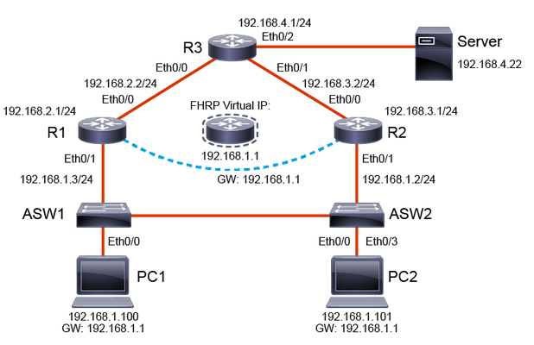

**Discovery 14: Implement NAT**

**Topology**

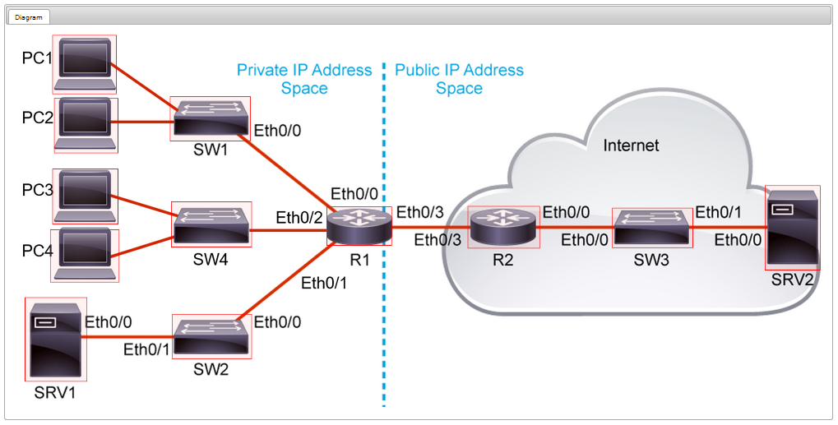

Job Aid

Device Information

| **Device** | **Characteristic** | **Value** |
| --- | --- | --- |
| PC1 | IP address | 10.10.1.10/24 |
| PC1 | Default gateway | 10.10.1.1 |
| PC1 | Eth0/0 | SW1 Eth0/1 |
| PC2 | IP address | 10.10.1.20/24 |
| PC2 | Default gateway | 10.10.1.1 |
| PC2 | Eth0/0 | SW1 Eth0/2 |
| PC3 | IP address | 10.10.3.10/24 |
| PC3 | Default gateway | 10.10.3.1 |
| PC3 | Eth0/0 | SW4 Eth0/1 |
| PC4 | IP address | 10.10.3.20/24 |
| PC4 | Default gateway | 10.10.3.1 |
| PC4 | Eth0/0 | SW4 Eth0/2 |
| SRV1 | IP address | 10.10.2.20/24 |
| SRV1 | Default gateway | 10.10.2.1 |
| SRV1 | Eth0/0 | SW2 Eth0/1 |
| SRV2 | IP address | 203.0.113.30/24 |
| SRV2 | Default gateway | 203.0.113.1 |
| SRV2 | Eth0/0 | SW3 Eth0/1 |
| SW1 | VLAN 1 IP address | 10.10.1.4/24 |
| SW1 | Default gateway | 10.10.1.1 |
| SW1 | Eth0/0 | R1 Eth0/0 |
| SW1 | Eth0/1 | PC1 Eth0/0 |
| SW1 | Eth0/2 | PC2 Eth0/0 |
| SW2 | VLAN 1 IP address | 10.10.2.4/24 |
| SW2 | Default gateway | 10.10.2.1 |
| SW2 | Eth0/0 | R1 Eth0/1 |
| SW2 | Eth0/1 | SRV1 Eth0/0 |
| SW3 | VLAN 1 IP address | 203.0.113.4/24 |
| SW3 | Default gateway | 203.0.113.1 |
| SW3 | Eth0/0 | R2 Eth0/0 |
| SW3 | Eth0/1 | SRV2 Eth0/0 |
| SW4 | VLAN 1 IP address | 10.10.3.4/24 |
| SW4 | Default gateway | 10.10.3.1 |
| SW4 | Eth0/0 | R1 Eth0/2 |
| SW4 | Eth0/1 | PC3 Eth0/0 |
| SW4 | Eth0/2 | PC4 Eth0/0 |
| R1 | Eth0/0 - 10.10.1.1/24 | SW1 Eth0/0 |
| R1 | Eth0/1 – 10.10.2.1/24 | SW2 Eth0/0 |
| R1 | Eth0/2 – 10.10.3.1/24 | SW4 Eth0/0 |
| R1 | Eth0/3 – 198.51.100.2/24 | R2 Eth0/3 |
| R2 | Eth0/0 – 203.0.113.1/24 | SW3 Eth0/0 |
| R2 | Eth0/3 – 198.51.100.1/24 | R1 Eth0/3 |

| Global IP Address Networks—Inside | | | | |
| --- | --- | --- | --- | --- |
| **Address Block** | **Host Starting Address** | **Host Ending Address** | **Broadcast Address** | **Subnet Mask** |
| 198.51.100.0/24 | 198.51.100.1 | 198.51.100.254 | 198.51.100.255 | 255.255.255.0 |

**Discovery 15: Configure and Verify VRF**

**Topology**

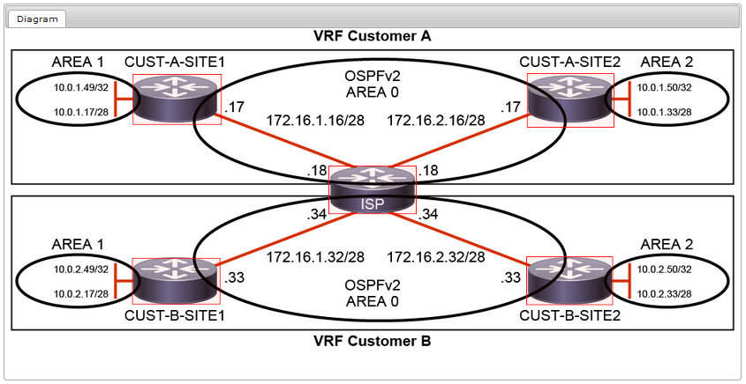

Job Aid

The configuration is as follows:

* All routers have their basic configurations in place, including hostnames and IP addresses.
* OSPFv2 is configured on all four Customer routers.

| **Device** | **Interface** | **IP Address** |
| --- | --- | --- |
| CUST-A-SITE1 | Ethernet 0/0 | 172.16.1.17/28 |
| CUST-A-SITE1 | Loopback 0 | 10.0.1.49/32 |
| CUST-A-SITE1 | Loopback 1 | 10.0.1.17/28 |
| CUST-A-SITE2 | Ethernet 0/1 | 172.16.2.17/28 |
| CUST-A-SITE2 | Loopback 0 | 10.0.1.50/32 |
| CUST-A-SITE2 | Loopback 1 | 10.0.1.33/28 |
| CUST-B-SITE1 | Ethernet 0/2 | 172.16.1.33/28 |
| CUST-B-SITE1 | Loopback 0 | 10.0.2.49/32 |
| CUST-B-SITE1 | Loopback 1 | 10.0.2.17/28 |
| CUST-B-SITE2 | Ethernet 0/3 | 172.16.2.33/28 |
| CUST-B-SITE2 | Loopback 0 | 10.0.2.50/32 |
| CUST-B-SITE2 | Loopback 1 | 10.0.2.33/28 |
| ISP | Ethernet 0/0 | 172.16.1.18/28 |
| ISP | Ethernet 0/1 | 172.16.2.18/28 |
| ISP | Ethernet 0/2 | 172.16.1.34/28 |
| ISP | Ethernet 0/3 | 172.16.2.34/28 |

**Discovery 16: Configure and Verify a GRE Tunnel**

**Topology**

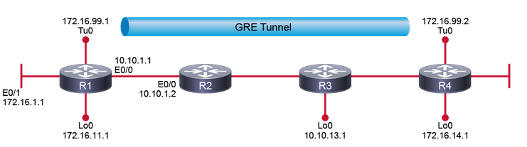

Job Aids

The configuration is as follows:

* All devices have their basic configurations in place, including hostnames and IP addresses.
* EIGRP is configured on R2 and R3.
* A static route is configured for 10.0.0.0/8 on R1 and R4.
* OSPF is configured on R1 and R4 after the tunnel is configured.

Device Information

| Device Details | | | |
| --- | --- | --- | --- |
| **Device** | **Interface** | **Neighbor** | **IP Address** |
| R1 | Ethernet0/0 | R2 | 10.10.1.1/24 |
| R1 | Ethernet0/1 | — | 172.16.1.1/24 |
| R1 | Loopback0 | — | 172.16.11.1/24 |
| R1 | Tunnel0 | R4 | 172.16.99.1 |
| R2 | Ethernet0/0 | R1 | 10.10.1.2/24 |
| R2 | Ethernet0/1 | R3 | 10.10.2.1/24 |
| R2 | Loopback0 | — | 10.10.12.1/24 |
| R3 | Ethernet0/0 | R4 | 10.10.3.1/24 |
| R3 | Ethernet0/1 | R2 | 10.10.2.2/24 |
| R3 | Loopback0 | — | 10.10.13.1/24 |
| R4 | Ethernet0/0 | R3 | 10.10.3.2/24 |
| R4 | Ethernet0/1 | — | 172.16.4.1/24 |
| R4 | Loopback0 | — | 172.16.14.1/24 |
| R4 | Tunnel0 | R1 | 172.16.99.2 |

**Discovery 17: Configure Static VTI Point-to-Point Tunnels**

**Topology**

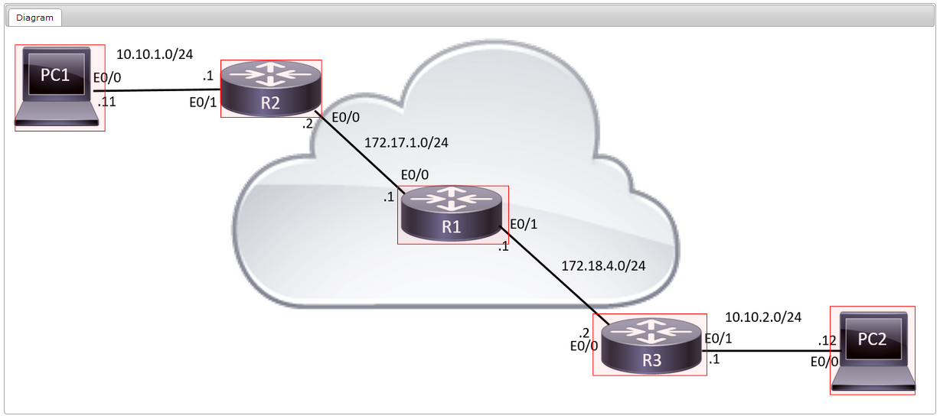

Command List

The table describes the commands that are used in this activity. The commands are listed in alphabetical order so that you can easily locate the information that you need. Refer to this list if you need configuration command assistance during the lab activity.

| **Command** | **Description** |
| --- | --- |
| authentication pre-share | In the crypto policy configuration mode, specifies authentication |
| clear crypto sa counters | Resets all crypto SA counters |
| crypto ipsec profile profile-name | Creates an IPsec profile and enters crypto profile configuration mode |
| crypto ipsec transform-set set-name esp-aes 128 esp-sha-hmac | Creates an IPsec transform set for user traffic protection with AES encryption algorithm and SHA-1 hash algorithm |
| crypto isakmp key key address peer-address | Creates a PSK and binds it to the IP address of the peer |
| crypto isakmp policy sequence | Creates a new IKE policy and enters crypto policy configuration mode |
| encr aes 128 | In the crypto policy configuration mode, specifies encryption algorithm |
| group 14 | In the crypto policy configuration mode, specifies the key exchange method |
| hash sha | In the crypto policy configuration mode, specifies hash algorithm |
| interface Tunnel0 | Creates a new tunnel interface and enters tunnel interface configuration mode |
| ip route network mask interface | Creates static routes to network that is reachable over the interface. |
| ip unnumbered interface | Assigns an IP subnet and address to the interface |
| lifetime lifetime | In the crypto policy configuration mode, specifies a lifetime |
| ping ip-destination source source-interface | Verifies IP connectivity between local interface and remote IP destination |
| set transform-set set-name | Configures nondefault transform set in the crypto profile |
| show crypto ipsec sa | Verifies the status of the IPsec SAs |
| show interface tunnel | Verifies the status of the local tunnel interface |
| show ip route | Displays IP routes |
| tunnel destination IP-address | Specifies a tunnel interface destination |
| tunnel mode ipsec ipv4 | Specifies the tunnel encapsulation as IPsec |
| tunnel protection ipsec profile profile-name | Specifies the traffic protection policy by referencing the configured IPsec profile |
| tunnel source interface | Specifies a tunnel interface source |

**Discovery 20: Configure Syslog**

**Topology**

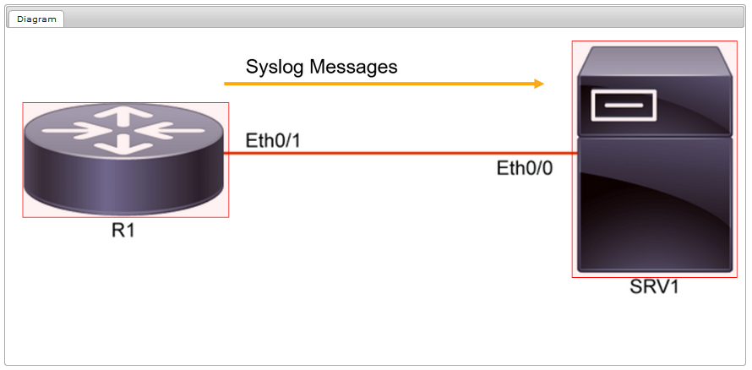

Job Aid

| Device Information Table | | |
| --- | --- | --- |
| **Device** | **Characteristic** | **Value** |
| SRV1 | Hostname | SRV1 |
| SRV1 | IP address | 10.1.1.10/24 |
| R1 | Hostname | R1 |
| R1 | Ethernet0/1 IP address | 10.1.1.1/24 |

**Discovery 21: Configure and Verify Flexible NetFlow**

**Topology**

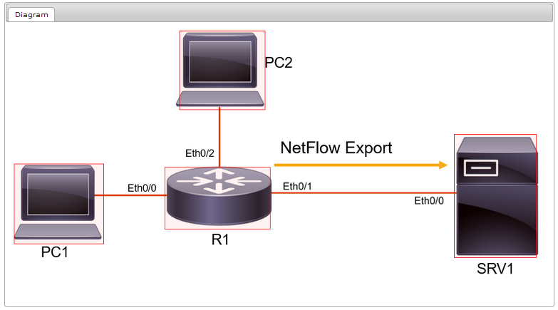

Job Aid

| **Device** | **Characteristic** | **Value** |
| --- | --- | --- |
| SRV1 | IP address | 10.1.1.10/24 |
| PC1 | IP address | 10.10.10.10/24 |
| PC2 | IP address | 10.20.20.10/24 |
| R1 | Ethernet0/0 IP address | 10.10.10.1/24 |
| R1 | Ethernet0/1 IP address | 10.1.1.1/24 |
| R1 | Ethernet0/2 IP address | 10.20.20.1/24 |
| R1 | Loopback0/0 IP address | 192.168.1.1/24 |

**Discovery 22: Configuring Cisco IOS Embedded Event Manager (EEM)**

**Topology**

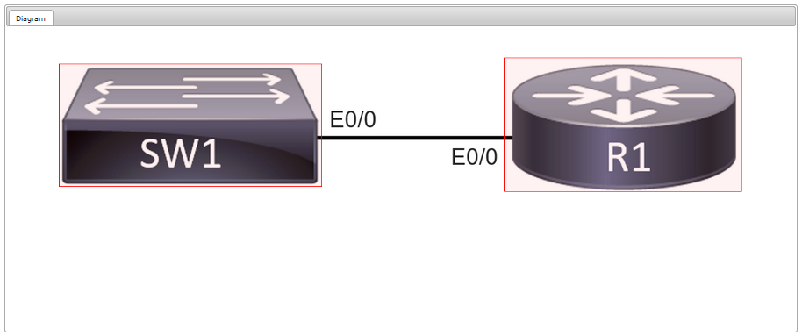

Job Aid

| Device Information | | | | | |
| --- | --- | --- | --- | --- | --- |
| **Device** | **Interface** | **Address** | **Device** | **Interface** | **Address** |
| SW1 | E0/0 |  | R1 | E0/0 | 192.168.1.1/24 |
| SW1 | VLAN1 | 192.168.1.2/24 |  |  |  |
| R1 | E0/0 | 192.168.1.1/24 | SW1 | E0/0 |  |

**Discovery 23: Troubleshoot Connectivity and Analyze Traffic with Ping, Traceroute, and Debug**

**Topology**

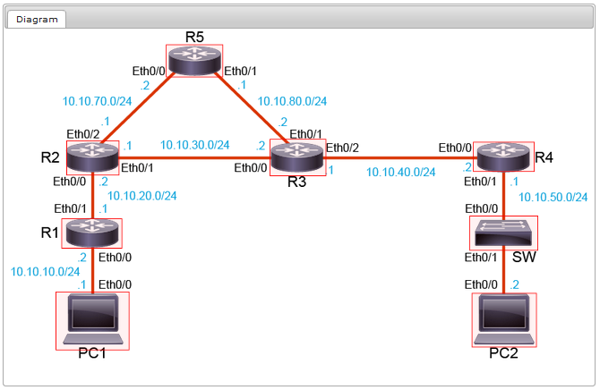

Job Aid

Note

If you shut down an interface on a real router or switch, the connected device will see it as "down/down." Due to virtualization specifics, IOL behavior is slightly different. If you shut down an interface on a router or switch, the connected device will see it as "up/up." In IOL, the status of an interface can only be "up/up" or "administratively down/down."

| Device Information | | | |
| --- | --- | --- | --- |
| **Device** | **Interface** | **Neighbor** | **IP Address** |
| PC1 | Ethernet 0/0 | R1 | 10.10.10.1/24 |
| R1 | Ethernet 0/0 | PC1 | 10.10.10.2/24 |
| R1 | Ethernet 0/1 | R2 | 10.10.20.1/24 |
| R2 | Ethernet 0/0 | R1 | 10.10.20.2/24 |
| R2 | Ethernet 0/1 | R3 | 10.10.30.1/24 |
| R2 | Ethernet 0/2 | R5 | 10.10.70.1/24 |
| R5 | Ethernet 0/0 | R2 | 10.10.70.2/24 |
| R5 | Ethernet 0/3 | R3 | 10.10.80.1/24 |
| R3 | Ethernet 0/1 | R5 | 10.10.80.2/24 |
| R3 | Ethernet 0/0 | R2 | 10.10.30.2/24 |
| R3 | Ethernet 0/2 | R4 | 10.10.40.1/24 |
| R4 | Ethernet 0/0 | R3 | 10.10.40.2/24 |
| R4 | Ethernet 0/1 | SW | 10.10.50.1/24 |
| SW | Ethernet 0/0 | R4 | N/A |
| SW | Ethernet 0/1 | PC2 | N/A |
| PC2 | Ethernet 0/0 | SW | 10.10.50.2/24 |

**Discovery 24: Configure and Verify Cisco IP SLAs**

**Topology**

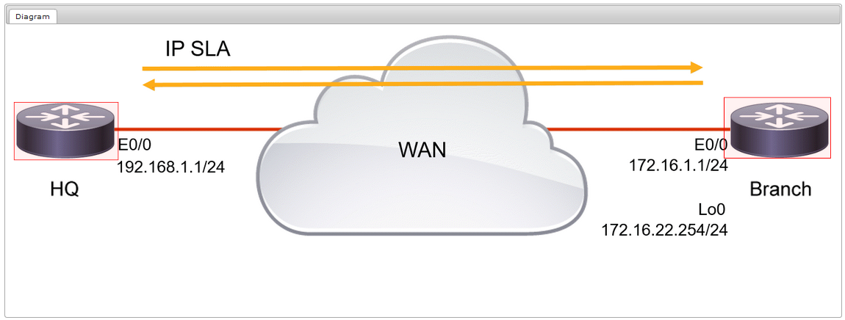

**Discovery 25: Configure Standard and Extended ACLs**

**Topology**

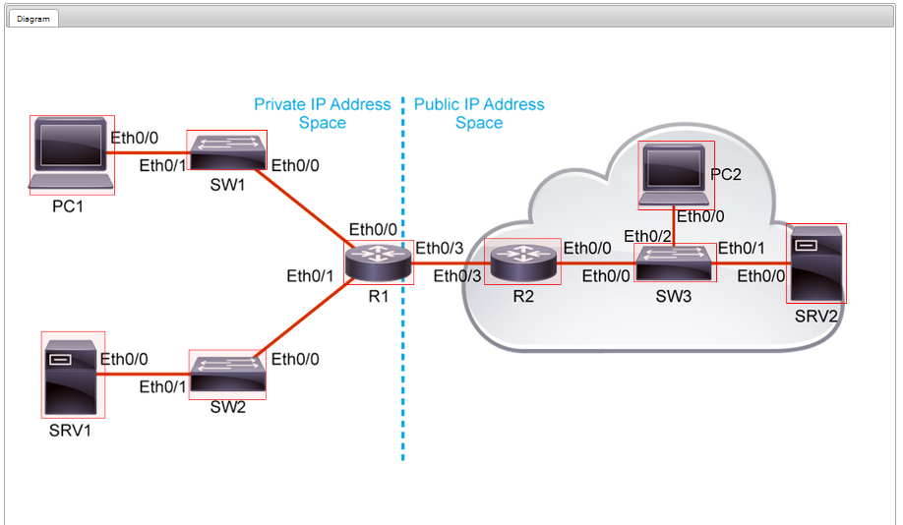

**Job Aid**

Device Information

The configuration is as follows:

* R1 and R2 have their basic configurations in place, including hostnames and IP addresses.
* Static routing is configured on R1 and R2.
* SRV1 and SRV2 are HTTP/HTTPS servers.
* SRV2 is a DNS server.
* The PC and SRVs in the virtual lab environment are simulated as routers, so you should use Cisco IOS commands to configure them or make verifications.

| Device Information Table | | |
| --- | --- | --- |
| **Device** | **Characteristic** | **Value** |
| PC1 | Ethernet 0/0 | 10.10.1.10/24 |
| PC2 | Ethernet 0/0 | 203.0.113.40/24 |
| SRV1 | Ethernet 0/0 | 10.10.2.20/24 |
| SRV2 | Ethernet 0/0 | 203.0.113.30/24 |
| R1 | Ethernet 0/0 | 10.10.1.1/24 |
| R1 | Ethernet 0/1 | 10.10.2.1/24 |
| R1 | Ethernet 0/3 | 198.51.100.2/30 |
| R2 | Ethernet 0/0 | 203.0.113.1/24 |
| R2 | Ethernet 0/3 | 198.51.100.1/30 |

**Discovery 26: Configure Control Plane Policing**

**Topology**

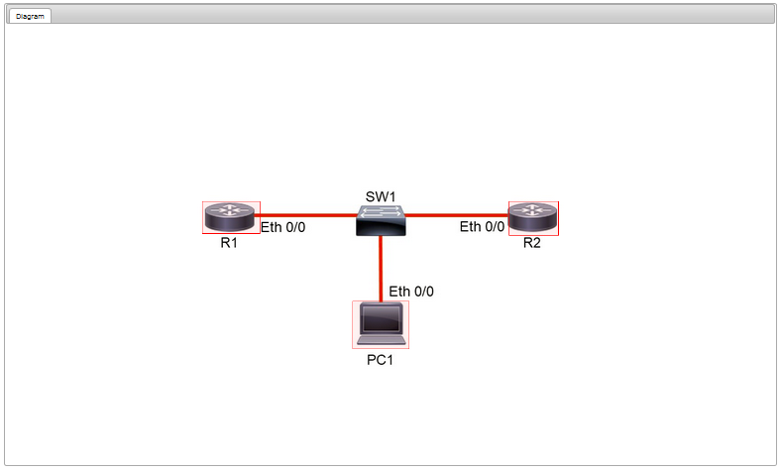

**Job Aid**

The configuration is as follows:

* R1 and R2 have their basic configurations in place, including hostnames and IP addresses.
* OSPFv2 routing is configured on R1 and R2.
* VRRP is configured on R1 and R2; R2 is the VRRP master and R1 is the VRRP Backup.
* The PC in the virtual lab environment is simulated as a router, so you should use Cisco IOS commands when performing testing.

| Device Information | | |
| --- | --- | --- |
| **Device** | **Interface** | **Interface** |
| PC1 | Ethernet 0/0 | 10.1.1.50/25 |
| R1 | Ethernet 0/0 | 10.1.1.1/24 |
| R2 | Ethernet 0/0 | 10.1.1.2/24 |
| R1 and R2 | VRRP virtual IP | 10.1.1.254 |

**Discovery 28: Writing and Troubleshooting Python Scripts**

**Topology**

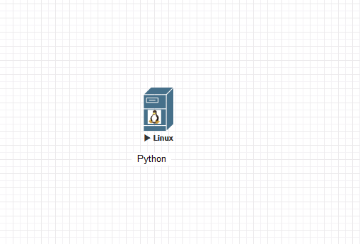

**Discovery 29: Explore JSON Objects and Scripts in Python**

**Topology**



**Discovery 30: Use NETCONF Via SSH**

**Topology**



**Discovery 31: Use RESTCONF with Cisco IOS XE Software**

**Topology**

